**Name:Yifan Li**

**Program:Full Stack Web Development**

**Course:Information System**

**Created : 2022-10-17**

**Operating Systems**

**Windows and Linux Command-Line Competency**

If you keep your terminal windows short, it will be much easier to screen capture.:

* For DOS (Windows CLI)
  + Start > Run (Windows key + R) then type:**cmd** and hit **<ENTER>**)
  + then type: **cls** then hit **<ENTER>** to clear/refresh your screen
  + Before you begin your Windows/DOS part, type in the following command:  
    **title C:\Users\%USERNAME%\CLI**
  + Right click the title bar, under **Layout** > **Window Size** > **Width**: change to **80** and click **OK** and thereafter, do not adjust the width of the Command Prompt window with your mouse’s window resizing capabilities, only the adjust the window height for your screenshots.
  + If you close your DOS window, you will need to do the previous steps again
  + Now you can begin your Windows/DOS Instructions
* For Linux
  + Login to your local Linux account (not root)
  + Use the command **clear** and press enter to clear the screen at anytime
  + Now you can start the Linux/Unix Instructions

1. When capturing your screenshots, enter in the commands required for the question, then do an <ALT><PRINT SCREEN>. Then insert from your clipboard into this document in the appropriate spot. This will save you a ton of time. You can also use **cls** or **clear** in tandem while following each question and resize the window height to show the commands/results. Just some tips for a successful and proper set of instructions, that are legible to yourselves, your graders/instructors and will give you a good understanding on how to do this in the real world.
2. In your home directory in both Windows and Linux, you will create the following directory structure:

* **CLI**
  + **dir01**
    - **subdirAA**
  + **dir02**
    - **subdirBA**
    - **subdirBB**
  + **dir10**
    - **subdirCA**

**Windows>DOS Instructions with Screenshots**

1. Create and enter the **CLI** directory using an absolute path (2 marks)dir

1. Create the 3 directories (**dir01**, **dir02**, **dir10**) using relative paths (3 marks)  
   **Text

   Description automatically generated**
2. Change to each directory and create the corresponding subdirectories (above) using relative paths (7 marks)

1. Change to your **CLI** directory (1 mark)

1. Create 3 files in **subdirAA** using relative paths: **file1**, **file2**, **file3** (3 marks)

1. Create 3 files in **subdirCA** using absolute paths: **file4**, **file5**, **file6** (3 marks)

1. Copy **file2** to **subdirBA** using an absolute path for both source and destination (2 marks)

1. Copy **file4** to **subdirBB** using a relative path for both source and destination (2 marks)

1. Demonstrate that both the copies worked (using a relative path for **subdirBA** and an absolute path for **subdirBB**) (2 marks)

1. Demonstrate that all folder and file creations have worked by doing one directory listing command (use /s/q parameters, will require 2 screenshots) (2 marks)

**(…CONTINUED…)**

1. Change to the **subdirBB** subdirectory and copy **file1** to this subdirectory (2 marks)

1. Delete **file5** in **subdirCA** using a relative path from the current directory (**subdirBB**) (1 mark)

1. Delete **file3** in **subdirAA** using an absolute path from the current directory (**subdirBB**) (1 mark)

1. Remove **dir10** using a relative path from the current directory (**subdirBB**) (1 mark)

1. Remove **dir01** using an absolute path (1 mark)

1. Change to your **CLI** directory (1 mark)

1. Remove **dir02** using relative paths (2 mark)

1. Verify that all **dir01**, **dir02**, **dir10** directories have been deleted (1 mark)

1. Remove the **CLI** directory using a relative path (1 mark)

**Linux Terminal Screenshots:**

Dear Teacher, Since my laptop’s OS is MacOS M1, it only supports Debian11 installation for now, so the interface is slightly different from Debian10, but the command line is the same.

1. Create and enter the **CLI** directory using absolute paths (2 marks)

1. Create the 3 directories (**dir01**, **dir02**, **dir10**) using relative paths (3 marks)

1. Change to each directory and create the corresponding subdirectories (above) using relative paths (7 marks)

1. Change to your **CLI** directory (1 mark)

1. Create 3 files in **subdirAA** using relative paths: **file1**, **file2**, **file3** (3 marks)

1. Create 3 files in **subdirCA** using absolute paths: **file4**, **file5**, **file6** (3 marks)

1. Copy **file2** to **subdirBA** using an absolute path for both source and destination (2 marks)

1. Copy **file4** to **subdirBB** using a relative path for both source and destination (2 marks)

1. Demonstrate that both the copies worked (using a relative path for **subdirBA** and an absolute path for **subdirBB**) (2 marks)

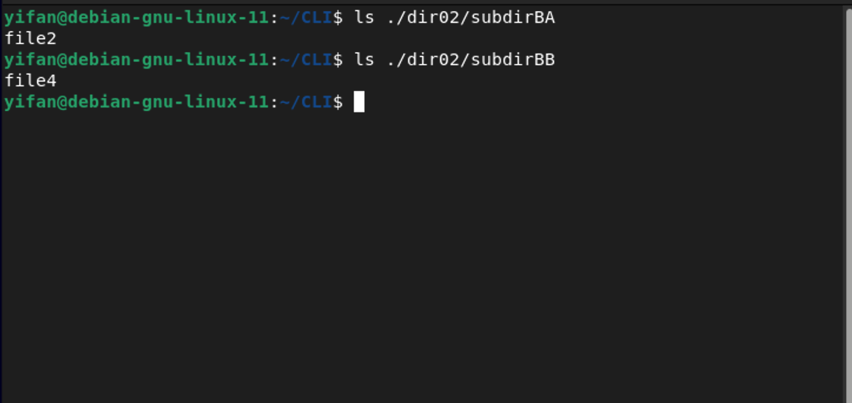

1. Demonstrate that all folder and file creations have worked by doing one directory listing command (using parameters -a lR and will require 2 screenshots) (2 marks)

**(…CONTINUED…)**

1. Change to the **subdirBB** subdirectory and copy **file1** to this subdirectory (2 marks)

1. Delete **file5** in **subdirCA** using a relative path from the current directory (**subdirBB**) (1 mark)

1. Delete **file3** in **subdirAA** using an absolute path from the current directory (**subdirBB**) (1 mark)

1. Remove **dir10** using a relative path from the current directory (**subdirBB**) (1 mark)

1. Remove **dir01** using an absolute path (1 mark)

1. Change to your **CLI** directory )1 mark)

1. Remove **dir02** using relative paths (2 marks)

1. Verify that all **dir01**, **dir02**, **dir10** directories have been deleted (1 mark)

1. Remove the **CLI** directory using a relative path (1 mark)

Total 76 Marks